**Practical:5**

**Aim: Establishing New System as BPR and Impact Analysis of new**

**System as BPR.**

**Business process reengineering (BPR)**:How to implement in a new system

* Business process reengineering (BPR) is the analysis and redesign of [workflows](http://searchcio.techtarget.com/definition/workflow) within and between enterprises in order to optimize end-to-end processes and automate non-value-added tasks.
* BPR implementation can be either successful or unsuccessful. A successful BPR implementation is considered to be one that yields the expected improvements in productivity and quality. An unsuccessful implementation is one that does not.

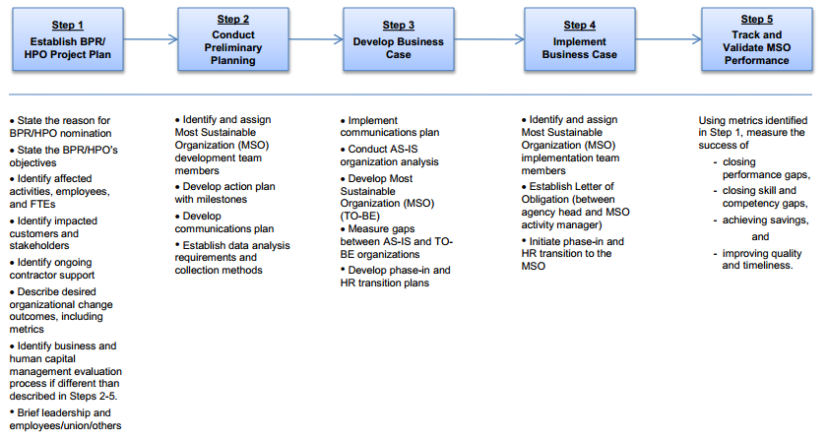

**Steps(to implement BPR in a new system ):**

### Implementation phases:

1. **Project kick off:** Project goal, project team and communication standards are agreed upon. A number of workshops are held where project scope, sponsors commitment, project risk, milestones and deliverables are discussed. A SWOT (strength, weakness, opportunities and threat) analysis is carried out with active participation of all.
2. **Process identification and data gathering:** “As is” processes are assembled through flow charts. Current practice of Interfacing with business partners is gathered. Bottlenecks, delays, complexity, internal blame games, idle assets etc. are brought forward. Use of existing technologies is comprehended. Major and strategic business processes to be reengineered, are identified. Stakeholders categorize the processes to be reengineered and agreed upon on the timeline of implementation.
3. **Process Reengineering:** In this phase, actual reengineering begins. A number of brain storming sessions are held with project team and other stakeholders, where current business processes are critically analyzed to determine non value adding activities and identify excess control and check, always with customer value as a focal point. Impact of new technologies on process improvement is also evaluated. New process ideas with reduced check and control and enabling technologies such as Workflow automation and ERP, are envisaged. Benchmarking is also done with best of breed industrial peers.
4. **Blueprint of new system:** Blueprinting involves modeling workflow and information requirement, of new business processes. “To be” processes are modeled using various modeling tools. New organization structures, human resource need, performance monitoring and compensation, technological needs, are also outlined. Normally, a first cut redesign scheme is produced which is modified after gathering actionable feedback from the stakeholders.
5. **Transformation:** A migration strategy and a migration plan is the first step of transformation. Migration strategy may decided as a pilot, phased or big bang implementation. The migration plan would include establishment of new organizational structure, detailed training and reallocation of workforce, and cut off dates for implementation. Change management and introduction of new technologies will form an important part and may need engagement of outside consultants for this specific purpose.

**Impact analysis of New System as BPR:**

* Past research has BPR proponents that suggest that BPR has serious effects on the organizational strategy and that it is a process that needs a proper approach to be followed if it is to bring expected success.
* The functionality and existence of any organization revolves around its strategy which is derived from its mission and vision. It is therefore important that the organizational strategy should be seriously considered during BPR in order for the resultant business processes to be a true representation of the organization.
* The mission statement where strategy is derivedfrom defines the purpose of the organization and describes what sets it apart from others in its sector. Vision statements serve as milestones which define where theorganization is going, thereby providing a clear picture of the desired future position for the organization.
* According to Hemal & Prahalad, 1994 in a business minor changes or improvements might not bring the success or affect the business directly to bring the results and BPR is a strategic option for the top managers of the businesses.
* Most importantly, the mission and the vision must be built into a clear organizational strategy that distinctly defines its competitive position if objectives are to be attained. The performance of each process is then measured at optimal level after BPR to ensure correct output with regards to what the process is supposed to do as well as alignment to organizational strategy.
* Hammer(2008) emphasizes that for BPR to succeed; it should be aligned to the organizational strategy. The issue of BPR/ organizational strategy alignment plays a very important role in organizations in the sense that BPR is change to business processes and business processes are a way to implement organizational strategy.
* BPR normally increase the competitiveness of the firm in the long run and short run. In the case of BPR, analysis shows this process consists of concealed and indescribable proportions which lead failure of this process.

**The Role of the Leader and the Manager:**

* Many articles point out that BPR must have the full support of top management to succeed. If resistance is encountered, the leader must be willing to "drive" change, even to the point of ruthlessness.
* One article even exhorts the leader to emulate a private detective -- such as Philip Marlowe -- who adheres to the following "heroic" qualities; Relentless adherence to what is right; Courage -- moral as well as physical; Recognition that surface appearance is often an illusion; A dogged determination to get at the deeper truth. Managers in a company undergoingreorganization must work to quell the fears of employees and resistance to change (despite the fact that they may have their own apprehensions.).
* According to one executive with BPR experience, "Once the [reengineering] plan is in place, you've got to pull out the stops and execute it.
* You cannot live in limbo between what you used to do and what you're going to do." Otherwise, the dramatic results are sacrificed, people lose their focus, and "reengineering slips into process improvement." Employees may be enthusiastic about reengineering during the initial phases if they view it as a "win- win" situation.
* Some companies experience resistance in later stages when employees begin to harbor doubts about the impact of reengineering, and managers are forced to adopt a more "insistent" policy.
* CSC Index points to poverty of ambition as a reason why BPR projects fail. "Companies that just flirt with [reengineering] suffer the pains without the gains." Reengineering advocates urge management to pull out all the stops and implement change on a grand scale.
* Managers in the organizations after reengineering are compared to coaches. They do not order; they guide. They do not direct the work of others; they coordinate, facilitate and empower.

### Examples of positive Impact in BPR:

* Many public and private sector organizations and SMEs Word-wide had undergone major reengineering efforts. Thetechnique was applied first to multinational co-operations, suchas IBM, AT&T, SONY, GENERAL ELECTRIC, WALL MART, HEWLLETPACKARD, DEC, KRAFT FOODS having as a result major downsizing in theirorganizational structures.
* Later, the banking sector began to reengineer with a great degree of success such as CITIBANK , NORTHWESTERN BANK, BANK OF AMERICA and others.
* A BPR effort on its IT infrastructure taught National Commercial Bank Jamaica Ltd. (NCBJ) an important lesson:
* To realize the big paybacks from such a project, you need to do a thorough, upfront analysis of business processes and workloads. Then you can optimize processes and allocate resources where they'll do the most good.
* First the government cabinet of Egypt reengineered its processes along with many Municipals in Europe. The public health sector is undergoing a major re-engineering in Europe using the CORBA methodology.

### Examples of negative Impact in BPR:

* The OR team had its work considerably hindered by the opposition posed by PubliCorp's staff. The OR group analyzed and modeled several processes with difficulty, which added uncertainty to the subsequent redesign proposals and related structural change. Additionally, two pilot process redesign attempts involving two distinct departments failed in the implementation phase, mainly due to lack of interest from staff.
* Another problem faced by the OR group was that some redesign proposals foundered on regulations established by law. The process of setting up public bids, for example, was identified as extremely complex and cluttered with several unnecessary activities. Moreover, this was one of the most frequently executed processes at PubliCorp.
* That process was analyzed and redesigned by the OR group several times. All redesign proposals were discussed with lawyers, regarding their legal validity. These discussions, though, found that most of the changes proposed might invalidate the result of future bids. Only slight changes in the process could really be implemented, without making the process prone to be contested by lawyers representing companies that had lost bids to others.

**THREE REASONS FOR THE FAILURE:**

**Political and objective goals were leveled:**

* One of the main problems every re-engineering group will face in a public organisation is the
* multitude of purposes that these organisations may have to serve. PubliCorp's CEO, supported bysome of its top management, was initially looking for radical quality and productivity improvement.
* However, the progress in the re-engineering attempt clearly indicates that he was prepared to acceptother results - provided that they were at least "apparently" positive.

**The OR group gradually shifted its focus:**

* The shift in the focus of the OR group, from re-engineering to process automation, is clear from thenarrative. However, during the re-engineering attempt that shift was not easy to perceive andtherefore to counter. This is particularly valid in cases where the radical process-focused
* characteristic of re-engineering is not well understood, or tends to be avoided due to barriers thatmay show up on the way. Two significant barriers to the OR group work at PubliCorp were thegeneral opposition faced from PubliCorp's staff, and the limitations on change imposed by law.

**A double bind prevented recovery:**

* In the case, the lack of understanding of the true nature of re-engineering did not seem to be themain reason why the focus of the re-engineering attempt moved from radical to incrementalimprovement. Even if some misunderstandings did exist, they seemed to have been combined withanother type of behavior, commonly observed in stressful business situations. This behaviorispresented by managers and decision makers faced with what is described by Argyris (1977) as a"double bind".
* The double bind comprises two norms, the one that says "hide errors" and its oppositethat says "reveal errors". If managers choose the first norm they know that what they do is necessaryyet counterproductive to the organization. If they choose the second norm, though, they riskexposing a whole network of camouflage and deception. The choice often lies on the less risky normthat says "hide errors".